**CNH Connect (CSPS):** CNH Connect (CSPS) is HBS Systems’ NetView version of CNH’s parts ordering dealer portal, CSPS. It allows CNH dealers using NetView software to view, edit, and send their CNH parts orders directly to CNH, as well as make buybacks, returns, claims, and various inquiries regarding orders, invoices, and CNH part availability. The dealer can also load all the necessary information to manage their CNH orders, as well as set up favored defaults for certain functions, using the extensive configuration options.

**NOTE: This program is for CNH dealers ONLY.**

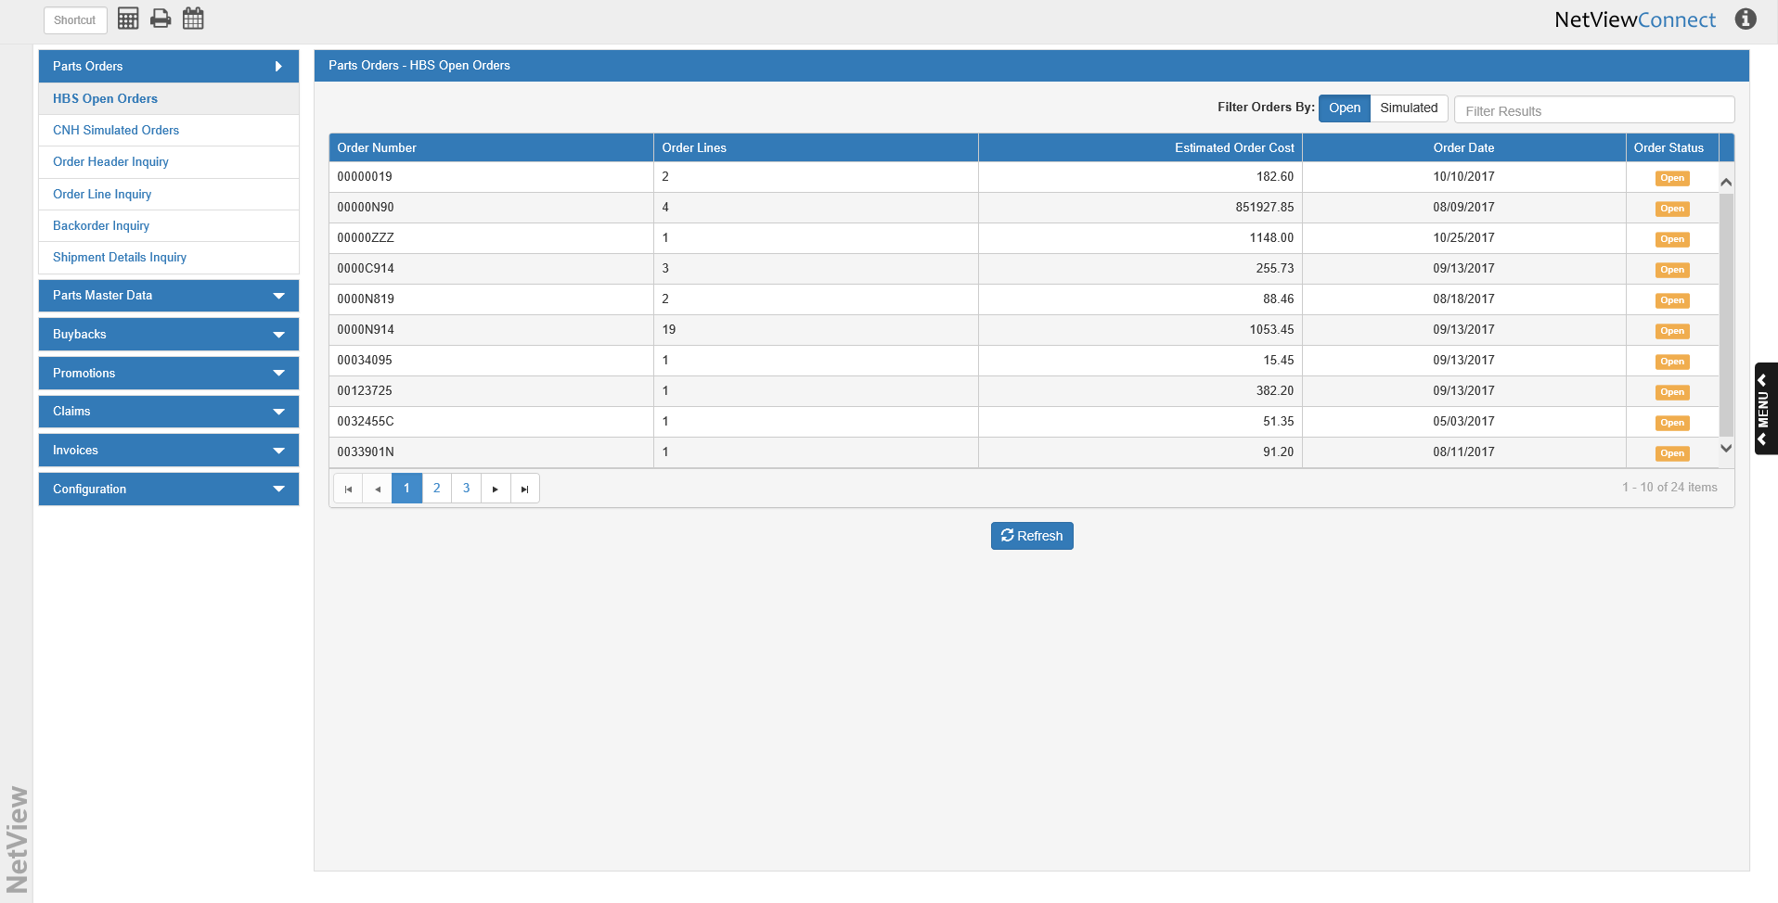

To access this function, type the shortcut **CSPS** into the Shortcuts Bar. The program will open in a new window, with the HBS Open Orders screen as the default display. The following topics will cover all the individual functions present in this program.